**Q1. Program of Exception handling**

x = input("Enter x: ")

y = input("Enter y: ")

try:

z = x + y

print("Result of addition:", z)

except TypeError:

print("Error: cannot add an int and a str")

finally:

print("End of program.")

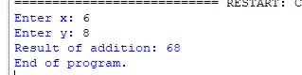

**Q2. Program to check whether number is divisible by zero or not**

x=input("enter no 1 : ")

y=input("enter no 2 : ")

try:

print(x/y)

except:

print("error 1")

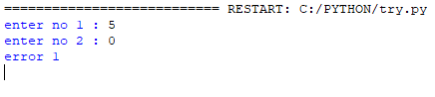

**Q3. Use concept of Finally**

x=input("enter no 1 : ")

y=input("enter no 2 : ")

try:

print(x/y)

except SystemError :

print("error 1")

except:

print("no")

finally:

print("Succesful")

**Q4. Perform Built in Exception any (5 Program)**

**ZeroDivisionError**

try:

result = 10 / 0

print("Result:", result)

except ZeroDivisionError:

print("Error: Division by zero!")



**ValueError**

try:

num = int(input("Enter an integer: "))

print("Entered number:", num)

except ValueError:

print("Error: Please enter a valid integer.")

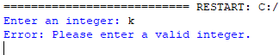

**TypeError**

try:

result = "hello" + 5

except TypeError:

print("Error: Unsupported operand type(s) for +.")



**FileNotFoundError**

try:

with open("a.txt", "r") as file:

content = file.read()

except FileNotFoundError:

print("Error: File not found.")



**NameError**

try:

print(undefined_variable)

except NameError:

print("Error: Variable is not defined.")



**Q5. Use Concept of Try, except and finally**

try:

x = int(input("Enter x: "))

y = int(input("Enter y: "))

z = x + y

print("Result of addition:", z)

except ValueError:

print("Error: Please enter valid integers.")

except TypeError:

print("Error: Cannot add an int and a str.")

finally:

print("End of program.")

